Child on Child Abuse Policy
(Including Sexual violence and Sexual harassment between children)

Swanbourne CE School

Mursley CE School

Drayton Parslow Village School

Kingfishers Pre-School (Mursley)

(In this policy known as the Three Schools)

This policy was adopted on – September 2026

The policy is to be reviewed by – September 2027

(Copies of this policy are available for staff, parents, visitors and volunteers on request from the school office).

Contents
1. Context and definition
2. Responsibility
3. Purpose of the policy
4. Framework and legislation
5. Abuse and harmful behaviour
6. Types of abuse
6.1. Physical abuse
6.2. Sexual violence and sexual harassment
6.3. Bullying
6.4. Online bullying
6.5. Sexting
6.6. Initiation / hazing
6.7. Prejudiced behaviour
6.8. Teenage relationship abuse
7. Expected staff action
8. Recognising Child on Child abuse
9. Points to consider
10. Next steps
11. Preventative strategies
Appendices 1 -5

1. Context and Definition
It is essential that all our staff understand the importance of challenging inappropriate behaviours between peers, and that as stated in KCSiE 2026 – Part five: Child-on-child sexual violence and sexual harassment;
451. Sexual violence and sexual harassment can occur between two or more children of any age and sex, from primary through to secondary stage and into college. It can occur also through a group of children sexually assaulting or sexually harassing a single child or group of children. Sexual violence and sexual harassment exist on a continuum and may overlap; they can occur online and face to-face (both physically and verbally) and are never acceptable. Schools and colleges should be aware of the importance of:
• making clear that there is a zero-tolerance approach to sexual violence and sexual harassment, that it is never acceptable, and it will not be tolerated. It should never be passed off as “banter”, “just having a laugh”, “a part of growing up” or “boys being boys”. Failure to do so can lead to a culture of unacceptable behaviour, an unsafe environment and in worst case scenarios a culture that normalises abuse, leading to children accepting it as normal and not coming forward to report it
• recognising, acknowledging, and understanding the scale of harassment and abuse and that even if there are no reports it does not mean it is not happening, it may be the case that it is just not being reported
• challenging physical behaviour (potentially criminal in nature) such as grabbing bottoms, breasts and genitalia, pulling down trousers, flicking bras and lifting up skirts. Dismissing or tolerating such behaviours risks normalising them. (KCSiE 2026)
Staff at The Three Schools who work with children are advised to maintain an attitude of ‘it could happen here’ where safeguarding is concerned. When concerned about the welfare of a child, staff should always act in the best interests of the child.
Child on child abuse is behaviour by an individual or group, intending to physically, sexually or emotionally hurt others.
All staff should recognise that children are capable of abusing their peers.
All staff should be aware of safeguarding issues from Child on Child abuse including:
- bullying (including online bullying)
- physical abuse such as hitting, kicking, shaking, biting, hair pulling, or otherwise causing physical harm
- sexual violence and sexual harassment
- sexting (also known as youth produced sexual imagery); and
- initiation/hazing type violence and rituals.
This abuse can:
- Be motivated by perceived differences e.g. on grounds of race, religion, gender, sexual orientation, disability or other differences
- Result in significant, long lasting and traumatic isolation, intimidation or violence to the victim; vulnerable adults are at particular risk of harm

Children or young people who harm others may have additional or complex needs e.g.:
- Significant disruption in their own lives
- Exposure to domestic abuse or witnessing or suffering abuse
- Educational under-achievement
- Involved in crime
Stopping violence and ensuring immediate physical safety is the first priority of any education setting, but emotional bullying can sometimes be more damaging than physical. School staff, alongside their Designated Safeguarding Lead and/or Deputy, have to make their own judgements about each specific case and should use this policy guidance to help.
All behaviour takes place on a spectrum. Understanding where a child's behaviour falls on a spectrum is essential to being able to respond appropriately to it.
In this policy we recognise the importance of distinguishing between problematic and abusive sexual behaviour (Harmful Sexual Behaviour HSB).
We are adopting the NSPCC definition of HSB as: -
"Sexual behaviours expressed by children…that are developmentally inappropriate, may be harmful towards self or others, or be abusive towards another child…or adult."
We will also use;
- Simon Hackett‘s continuum model to demonstrate the range of sexual behaviours (Appendix 1)
- The Brook Traffic Lights (Appendix 2)
Vulnerable groups
We recognise that all children can be at risk however we acknowledge that some groups are more vulnerable. This can include: experience of abuse within their family; living with domestic violence; young people in care; children who go missing; children with additional needs (SEN and/or disabilities); children who identify or are perceived as LGBT and/or have other protected characteristics under the Equalities Act 2010.
Whist research tells us girls are more frequently identified as being abused by their peers and, girls are more likely to experience unwanted sexual touching in schools this is not confined to girls.
Boys are less likely to report intimate relationship abuse and may display other behaviour such as antisocial behaviour. Boys report high levels of victimisation in areas where they are affected by gangs. We recognise that both boys and girls experience child on child abuse, but they do so in gendered ways.
All staff should be aware of indicators, which may signal that children are at risk from, or are involved with serious violent crime. These may include increased absence from school, a change in friendships or relationships with older individuals or groups, a significant decline in performance, signs of self-harm or a significant change in wellbeing, or signs of assault or unexplained injuries. Unexplained gifts or new possessions could also indicate that children have been approached by, or are involved with, individuals associated with criminal networks or gangs.

2. Responsibility
Keeping Children Safe in Education (KCSIE) 2026 states that;
‘Governing bodies and proprietors should ensure their child protection policy includes procedures to minimise the risk of child on child abuse and sets out how allegations of child on child abuse will be investigated and dealt with’.
It also emphasises that the voice of the child must be heard ‘Governing bodies, proprietors and school or college leaders should ensure the child’s wishes and feelings are taken into account when determining what action to take and what services to provide. Systems should be in place for children to express their views and give feedback. Ultimately, all system and processes should operate with the best interests of the child at their heart.’
Child on Child abuse is referenced in the Safeguarding and Child Protection Policy. The sensitive nature and specific issues involved with Child on Child abuse necessitate separate policy guidance.
At The Three Schools we continue to ensure that any form of abuse or harmful behaviour is dealt with immediately and consistently to reduce the extent of harm to the young person, with full consideration to the impact on that individual child’s emotional and mental health and well-being.
3. Purpose of Policy
The purpose of this policy is to explore some forms of Child on Child abuse. The policy also includes a planned and supportive response to the issues.
At The Three Schools we have the following policies in place that should be read in conjunction with this policy:
3.1 Anti-Bullying Policy (including Online Bullying Policy)
3.2 Safeguarding and Child Protection Policy
3.3 Managing Allegations / Whistleblowing Policy
3.4 Positive Behaviour Policy
3.5 Health & Safety Policy
3.6 Online Safety Policy
3.7 Sex Education Policy
3.8 Relationships Education Policy
3.9 PSHE Policy

4. Framework and Legislation
This policy is supported by the key principles of the Children’s Act, 1989 that the child’s welfare is paramount. Another key document is Working Together, 2026, highlighting that every assessment of a child, ‘must be informed by the views of the child’. (Working Together, 2026) This is echoed by Keeping Children Safe in Education, 2026 through ensuring procedures are in place in schools and settings to hear the voice of the child.
5. Abuse and harmful behaviour
It is necessary to consider;
- what abuse is and what it looks like
- how it can be managed
- what appropriate support and intervention can be put in place to meet the needs of the individual
- what preventative strategies may be put in place to reduce further risk of harm.
Abuse is abuse and should never be tolerated or passed off as ‘banter’ or ‘part of growing up’. It is important to consider the forms abuse may take and the subsequent actions required.
- Children are vulnerable to abuse by their peers. Such abuse should be taken as seriously as abuse by adults and should be subject to the same child protection procedures.
- Children can abuse other children. This can include (but is not limited to): abuse within intimate partner relationships; bullying (including cyberbullying); sexual violence and sexual harassment; physical abuse such as hitting, kicking, shaking, biting, hair pulling, or otherwise causing physical harm; sexting and initiation/hazing type violence and rituals.
- Staff should not dismiss abusive behaviour as normal between young people and should not develop high thresholds before taking action.
- Staff should be aware of the potential uses of information technology for bullying and abusive behaviour between young people.
- Staff should be aware of the added vulnerability of children and young people who have been the victims of violent crime (for example mugging), including the risk that they may respond to this by abusing younger or weaker children.
The alleged perpetrator is likely to have considerable unmet needs as well as posing a significant risk of harm to other children. Evidence suggests that such children may have suffered considerable disruption in their lives, may have witnessed or been subjected to physical or sexual abuse, may have problems in their educational development and may have committed other offences. They may therefore be suffering, or be at risk of suffering, significant harm and be in need of protection. Any long-term plan to reduce the risk posed by the alleged perpetrator must address their needs.
6. Types of abuse
There are many forms of abuse that may occur between peers and this list is not exhaustive.
Each form of abuse or prejudiced behaviour is described in detail followed by advice and support on actions to be taken.
6.1 Physical abuse
This may include hitting, kicking, nipping/pinching, shaking, biting, hair pulling, or otherwise causing physical harm to another person. There may be many reasons why a child harms another and it is important to understand why a young person has engaged in such behaviour, including accidently before considering the action or punishment to be undertaken.
6.2 Sexual violence and sexual harassment
As shown in the guidance; Keeping Children Safe in Education 2026 - Part five: Child-on-child sexual violence and sexual harassment (Appendix 3) 447. Sexual violence and sexual harassment can occur between two or more children of any age and sex, from primary through to secondary stage and into college. It can occur also through a group of children sexually assaulting or sexually harassing a single child or group of children. Sexual violence and sexual harassment exist on a continuum and may overlap; they can occur online and face-to-face (both physically and verbally) and are never acceptable.
Responding to Alleged Incidents, Responding to reports of sexual violence and sexual harassment
All reports of Child on Child abuse will be made on a case by case basis with the designated safeguarding lead or their deputy taking a leading role using their professional judgement and supported by other agencies such as social care or the police as required (See section 10 – Next Steps).
Support for Children Affected by Sexual-Assault
Support for victims of sexual assault is available from a variety of agencies (Appendix 4). We will support the victim of sexual assault, to remain in school but if they are unable to do so we will enable them to continue their education elsewhere. This decision will be made only at the request of the child and their family.
If they are moved, we will ensure the new school is aware of the ongoing support they may need. The DSL will support this move.
Where there is a criminal investigation the alleged perpetrator will be removed from any shared classes with the victim and we will also consider how best to keep them a reasonable distance apart on the school premises or on school transport. This is in the best interest of the children concerned and should not be perceived to be a judgement of guilt before any legal proceedings. We will work closely with the police.
Where a criminal investigation into a rape or assault by penetration leads to a conviction or caution, we may take suitable action, if we have not already done so. In all but the most exceptional of circumstances, the rape or assault is likely to constitute a serious breach of discipline and lead to the view that allowing the perpetrator to remain in the same school or college would seriously harm the education or welfare of the victim (and potentially other pupils or students).
Where a criminal investigation into sexual assault leads to a conviction or caution, we may, if we have not already done so, consider any suitable sanctions using our behaviour policy, including consideration of permanent exclusion.
Where the perpetrator is going to remain at the school or college, the principle would be to continue keeping the victim and perpetrator in separate classes and continue to consider the most appropriate way to manage potential contact on school and college premises and transport. The nature of the conviction or caution and wishes of the victim will be especially important in determining how to proceed in such cases.
Reports of sexual assault and sexual harassment will, in some cases, not lead to a report to the police (for a variety of reasons). In some cases, rape, assault by penetration, sexual assault or sexual harassment are reported to the police and the case is not progressed or are reported to the police and ultimately result in a not guilty verdict. None of this means the offence did not happen or that the victim lied. The process will have affected both victim and alleged perpetrator. Appropriate support will be provided to both as required and consideration given to sharing classes and potential contact as required on a case-by-case basis.
All the above will be considered with the needs and wishes of the victim at the heart of the process (supported by parents and carers as required). Any arrangements should be kept under review.
6.3 Bullying
Bulling is unwanted, aggressive behaviour among school aged children that involves a real or perceived power imbalance. The behaviour is repeated, or has the potential to be repeated, over time. Both young people who are bullied and who bully others may have serious, lasting problems.
In order to be considered bullying, the behaviour must be aggressive and include:
- An Imbalance of Power: Young people who bully use their power—such as physical strength, access to embarrassing information, or popularity—to control or harm others. Power imbalances can change over time and in different situations, even if they involve the same people.
- Repetition: Bullying behaviours happen more than once or have the potential to happen more than once.
Bullying includes actions such as making threats, spreading rumours, attacking someone physically or verbally or for a particular reason e.g. size, hair colour, gender, sexual orientation, and excluding someone from a group on purpose.
6.4 Online Bulling
Online Bullying is the use of technology (social networking, messaging, text messages, e-mail, chat rooms etc.) to harass threaten or intimidate someone for the same reasons as stated above.
Online bullying can take many forms
- Abusive or threatening texts, emails or messages
- Posting abusive comments on social media sites
- Sharing humiliating videos or photos of someone else
- Stealing someone’s online identity
- Spreading rumours online
- Trolling – sending someone menacing or upsetting messages through social networks, chatrooms or games
- Developing hate sites about another person
- Prank calls or messages
- Group bullying or exclusion online
- Anonymous messaging
- Encouraging a young person to self-harm
- Pressuring children to send sexual messages or engaging in sexual conversations
6.5 Sexting / Sharing nude or indecent imagery
The term ‘sexting’ relates to the sending of indecent images, videos and/or written messages with sexually explicit content; these are created and sent electronically. They are often ‘shared’ via social networking sites and instant messaging services.
Up-skirting: typically involves taking a picture under a person’s clothing without them knowing, with the intention of viewing their genitals or buttocks to obtain sexual gratification, or cause the victim humiliation, distress or alarm. It is a criminal offence. Anyone of any gender, can be a victim.
This must always be referred immediately to the Designated Safeguarding Lead DSL will follow the UKCIS: Sexting in schools and colleges 2016 guidance.
https://www.gov.uk/government/uploads/system/uploads/attachment_data/file/551575/6.2439_KG_NCA_Sexting_in_Schools_WEB 1_.PDF
6.6 Initiation/Hazing
Hazing is a form of initiation ceremony which is used to induct newcomers into an organisation such as a private school, sports team etc. There are a number of different forms, from relatively mild rituals to severe and sometimes violent ceremonies. The ceremony welcomes newcomers by subjecting them to a series of trials which promote a bond between them.
After the hazing is over, the newcomers also have something in common with older members of the organisation, because they all experienced it as part of a rite of passage. Many rituals involve humiliation, embarrassment, abuse, and harassment.
6.7 Prejudiced Behaviour
The term prejudice-related bullying refers to a range of hurtful behaviour, physical or emotional or both, which causes someone to feel powerless, worthless, excluded or marginalised, and which is connected with prejudices around belonging, identity and equality in wider society – for example disabilities and special educational needs, ethnic, cultural and religious backgrounds, gender, home life, (for example in relation to issues of care, parental occupation, poverty and social class) and sexual identity.
6.8 Teenage relationship abuse
Teenage relationship abuse is a pattern of actual or threatened acts of physical, sexual, and/or emotional abuse, perpetrated by an adolescent (between the ages of 13 and 18) against a current or former partner. Abuse may include insults, coercion, social sabotage, sexual harassment, threats and/or acts of physical or sexual abuse. The abusive teen uses this pattern of violent and coercive behaviour, in a heterosexual or same gender relationship, in order to gain power and maintain control over the partner. This abuse may be child sexual exploitation.
7. Expected staff action
When responding to Alleged Incidents, responding to reports of sexual violence and sexual harassment, staff should consider the seriousness of the case and make a quick decision whether to inform the Designated Safeguarding Lead immediately before taking any further in-school actions.
All reports of Child on Child abuse will be made on a case by case basis with the designated safeguarding lead or their deputy taking a leading role using their professional judgement and supported by other agencies such as social care or the Police as required.
The immediate response to a report
- The school or college will take all reports seriously and will reassure the victim that they will be supported and kept safe.
- All staff will be trained to manage a report.
- Staff will not promise confidentiality as the concern will need to be shared further (for example, with the designated safeguarding lead or social care) staff will however only share the report with those people who are necessary to progress it.
It is important to deal with a situation of Child on Child abuse immediately and sensitively. It is necessary to gather the information as soon as possible to get the true facts. It is equally important to deal with it sensitively and think about the language used and the impact of that language on both the children and the parents when they become involved. Avoid language that may create a ‘blame’ culture and leave a child labelled.
Staff will talk to the children in a calm and consistent manner. Staff will not be prejudiced, judgmental, dismissive or irresponsible in dealing with such sensitive matters.
8. Recognising Child on Child abuse
An assessment of an incident between children should be completed and consider:
- Chronological and developmental ages of everyone involved
- Difference in their power or authority in relation to age, race, gender, physical, emotional or intellectual vulnerability
- All alleged physical and verbal aspects of the behaviour and incident
- Whether the behaviour involved inappropriate sexual knowledge or motivation
- What was the degree of physical aggression, intimidation, threatening behaviour or bribery
- The effect on the victim
- Any attempts to ensure the behaviour and incident is kept a secret
- The child or young person’s motivation or reason for the behaviour, if they admit that it occurred
- Whether this was a one-off incident, or longer in duration
8.1 Taking Action
- Always take complaints seriously
- Gain a statement of facts from the pupil(s)
- Assess needs of victim and alleged perpetrator
- Consider referral to Police or Social Care
- Contribute to multi-agency assessments
- Convene a risk management meeting
- Record all incidents and all action taken
8.2 Recording sexualised behaviour
- Be clear, explicit and non-avoidant, and avoid vague statements or euphemisms
- Record as soon as possible, as you can quickly forget or confuse detail
- Follow the prompts on your safeguarding and child protection recording form
- Use proper names for body parts but record exactly any language or vocabulary used by the child. Use the child’s exact words in quotation marks.
- Note where and when the incident happened and whether anyone else was around.
8.3 Gather the Facts
Speak to all the young people involved separately, gain a statement of facts from them and use consistent language and open questions for each account. Ask the young people to tell you what happened. Use open questions, ‘where, when, why, who’. (What happened? Who observed the incident? What was seen? What was heard? Did anyone intervene?). Do not interrogate or ask leading questions.
8.4 Consider the Intent
Has this been a deliberate or contrived situation for a young person to be able to harm another?
8.5 Decide on your next course of action
If you believe any young person to be at risk of significant harm you must report to the Designated Safeguarding Lead immediately; they will follow the school’s Safeguarding and Child Protection Policy.
If MASH and the police intend to pursue this further, they may ask to interview the young people in school or they may ask for parents to come to school to be spoken to. It is important to be prepared for every situation and the potential time it may take.
8.6 Informing parents/carers
The best way to inform parents/carers is face to face. Although this may be time consuming, the nature of the incident and the type of harm/abuse a young person may be suffering can cause fear and anxiety to parents/carers whether their child is the child who was harmed or who harmed another.
Is the pupil 13+ and does not want to share with parents? Use the ‘Gillick’ test and the ‘Fraser’ guidelines.
https://www.nspcc.org.uk/preventing-abuse/child-protection-system/legal-definition-childrights-law/gillick-competency-fraser-guidelines/
In all circumstances where the risk of harm to the child is evident then the school should encourage the young person to share the information with their parent/carer (they may be scared to tell parents/carers that they are being harmed in any way).
9. Points to consider
9.1 What is the age of the children involved?
How old are the young people involved in the incident and is there any age difference between those involved? In relation to sexual exploration, children under the age of 5, in particular 1-4 year olds who are learning toileting skills may show a particular interest in exploration at around this stage. This, however, should not be overlooked.
9.2 Where did the incident or incidents take place?
Was the incident in an open, visible place to others? If so, was it observed? If not, is more, supervision required within this particular area?
9.3 What was the explanation by all children involved of what occurred?
Can each of the young people give the same explanation of the incident and also what is the effect on the young people involved? Is the incident seen to be bullying for example, in which case regular and repetitive? Is the version of one young person different from another and why?
9.4 What is each of the children’s own understanding of what occurred?
Do the young people know/understand what they are doing? E.g. do they have knowledge of body parts, of privacy and that it is inappropriate to touch? Is the young person’s explanation in relation to something they may have heard or been learning about that has prompted the behaviour? Is the behaviour deliberate and contrived? Does the young person have an understanding of the impact of their behaviour on the other person?
9.5 Repetition
Has the behaviour been repeated to an individual on more than one occasion? In the same way it must be considered has the behaviour persisted to an individual after the issue has already been discussed or dealt with and appropriately resolved?

10. Next Steps
Once the outcome of the incident(s) has been established it is necessary to ensure future incidents of abuse do not occur again and consider the support and intervention required for those involved.
10.1 Risk Assessment
When there has been a report of sexual violence, the designated safeguarding lead (or a deputy) will make an immediate risk and needs’ assessment (Appendix 5). Where there has been a report of sexual harassment, the need for a risk assessment should be considered on a case-by-case basis. The risk and needs’ assessment should consider:
- The victim, especially their protection and support;
- The alleged perpetrator; and
- All the other children (and, if appropriate, adult students and staff) at the school or college, especially any actions that are appropriate to protect them;
Risk assessments (Appendix 5) will be recorded in a written format and will be filed with other confidential files in the Headteacher’s office, and be kept under review.
The designated safeguarding lead (or a deputy) will ensure they are engaging with MASH.
Action following a report of sexual violence and/or sexual harassment
Following an incident, we will consider
- The wishes of the victim in terms of how they want to proceed. This is especially important in the context of sexual violence and sexual harassment;
- The nature of the alleged incident(s), including: whether a crime may have been committed and
consideration of harmful sexual behaviour;
- The ages of the children involved;
- The developmental stages of the children involved;
- Any power imbalance between the children. For example, is the alleged perpetrator significantly older, more mature or more confident? Does the victim have a disability or learning difficulty?
- If the alleged incident is a one-off or a sustained pattern of abuse;
- Are there ongoing risks to the victim, other children, adult students or school or college staff; and other related issues and wider context?
10.2 For the young person who has been harmed
What support they require depends on the individual young person? It may be that they wish to seek counselling or one to one support via a mentor. It may also be that they feel able to deal with the incident(s) on their own or with support of family and friends; in which case it is necessary that this young person continues to be monitored and offered support should they require it in the future. If the incidents are of a bullying nature, the young person may need support in improving peer groups/relationships with other young people, or some restorative justice work with all those involved may be required.
Other interventions that could be considered may target a whole class or year group for example a speaker on online bullying, relationship abuse etc. It may be that through PSHE or group sessions that the matter can be addressed for the young person and whole group.

10.3 For the young person who has displayed harmful behaviour
It is important to find out why the young person has behaved in such a way. It may be that the young person is experiencing their own difficulties and may even have been harmed themselves in a similar way. In such cases support such as one to one mentoring or counselling may also be necessary.
Particular support from identified services may be necessary through an early help referral and the young person may require additional support from family members.
Once the support required to meet the individual needs of the young person has been met, it is important that the young person receives a consequence for their behaviour. This may be in the form of restorative justice e.g. making amends with the young person they have targeted if this has been some form of bullying. In the cases of sexually harmful behaviour it may be a requirement for the young person to engage in one to one work with a particular service or agency (if a crime has been committed this may be through the police or youth offending service). If there is any form of criminal investigation ongoing it may be that this young person cannot be educated on site until the investigation has concluded. In which case, the young person will need to be provided with appropriate support and education elsewhere.
It may be that the behaviour that the young person has displayed may continue to pose a risk to others, in which case an individual risk assessment may be required. This should be completed via a multi- agency response to ensure that the needs of the young person and the risks towards others are measured by all of those agencies involved including the young person and their parents.
This may mean additional supervision of the young person or protective strategies if the young person feels at risk of engaging in further inappropriate or harmful behaviour.
The school may also choose a punishment as a consequence such as exclusion or internal exclusion/inclusion/seclusion for a period of time to allow the young person to reflect on their behaviour.
10.4 After care
It is important that following the incident the young people involved continue to feel supported and receive help even if they have stated that they are managing the incident.
Sometimes the feelings of remorse, regret or unhappiness may occur at a much later stage than the incident. It is important to ensure that the young people do not engage in any further harmful behaviour either towards someone else or to themselves as a way of coping (e.g. self-harm). For this reason, regular reviews with the young people following the incident(s) are imperative.
10.5 Reporting to the Police
Any report to the police will generally be made through the MASH as above. The designated safeguarding lead (and their deputies) will follow local processes for referrals.
Where a report of rape, assault by penetration or sexual assault is made, the starting point is this will be passed on to the police. Whilst the age of criminal responsibility is ten, if the alleged perpetrator is under ten, the starting principle of reporting to the police remains. The police will take a welfare, rather than a criminal justice, approach.
Where a report has been made to the police, the school or college will consult the police and agree what information can be disclosed to staff and others, the alleged perpetrator and their parents or carers. They will also discuss the best way to protect the victim and their anonymity.
Where there is a criminal investigation, we will work closely with the relevant agencies to support all children involved (especially potential witnesses). Where required, advice from the police will be sought in order to help us.
Whilst protecting children and/or taking any disciplinary measures against the alleged perpetrator, we will work closely with the police (and other agencies as required), to ensure any actions the school or college take do not jeopardise the police investigation.
10.6 The end of the criminal process
If a child is convicted or receives a caution for a sexual offence, the school /academy will update its risk assessment, ensure relevant protections are in place for all children. We will consider any suitable action following our Positive Behaviour policy. If the perpetrator remains in school/academy we will be very clear as to our expectations regarding the perpetrator now they have been convicted or cautioned. This could include expectations regarding their behaviour and any restrictions we think are reasonable and proportionate about the perpetrator’s timetable.
Any conviction (even with legal anonymity reporting restrictions) is potentially going to generate interest among other pupils or students in the school or college.
We will ensure all children involved are protected, especially from any bullying or harassment (including online).
Where cases are classified as “no further action” (NFA’d) by the police or Crown Prosecution Service, or where there is a not guilty verdict, we will continue to offer support to the victim and the alleged perpetrator for as long as is necessary. A not guilty verdict or a decision not to progress with their case will likely be traumatic for the victim. The fact that an allegation cannot be substantiated does not necessarily mean that it was unfounded. We will continue to support all parties in this instance.
11. Preventative Strategies
Child on Child abuse can and will occur on any site even with the most robust policies and support processes. It is important to develop appropriate strategies to proactively prevent Child on Child abuse.
- Our schools have an open environment where young people feel safe to share information about anything that is upsetting or worrying them. There is a strong and positive PSHE/RSHE curriculum that tackles such issues as prejudiced behaviour and gives children an open forum to talk things through rather than seek one on one opportunities to be harmful to one another. The schools makes sure that ‘support and report’ signposting is available to young people.
- Pupils are frequently told what to do if they witness or experience such abuse, the effect that it can have on those who experience it and the possible reasons for it, including vulnerability of those who inflict such abuse.
Staff will not dismiss issues as ‘banter’ or ‘growing up’ or compare them to their own experiences of childhood. Staff will consider each issue and each individual in their own right before taking action.
Young people are part of changing their circumstances and, through school council and pupil voice for example, we encourage young people to support changes and develop ‘rules of acceptable behaviour’. We involve pupils in the positive ethos in school; one where all young people understand the boundaries of behaviour before it becomes abusive.

The Three Schools actively seek to raise awareness of and prevent all forms of Child-on-Child abuse by:
- Educating all Governors, Senior Leadership Team, staff and volunteers and parents about this issue. This will include training all Governors, Senior Leadership Team, staff and volunteers on the nature, prevalence and effect of Child on Child abuse, and how to prevent, identify and respond to it. This includes
(a) Contextual Safeguarding;
(b) The identification and classification of specific behaviours; and
(c) The importance of taking seriously all forms of Child-on-Child abuse (no matter how low level they may appear) and ensuring that no form of Child-on-Child abuse is ever dismissed as horseplay or teasing.
Multi-agency working
The School actively engages with its local partners in relation to Child-on-Child, and works closely with, Buckinghamshire Safeguarding Children Partnership (NSCP), Buckinghamshire Multi-Agency Safeguarding Hub (MASH), children's social care, and/or other relevant agencies, and other schools.
The relationships The Three Schools has built with these partners are essential to ensuring that the Schools are able to prevent, identify early and appropriately handle cases of Child on Child abuse. They help The Three Schools;
(a) To develop a good awareness and understanding of the different referral pathways that operate in its local area, as well as the preventative and support services which exist;
(b) To ensure that our pupils can access the range of services and support they need quickly;
(c) To support and help inform our local community's response to Child-on-Child abuse;
(d) To increase our awareness and understanding of any concerning trends and emerging risks in our local area to enable us to take preventative action to minimise the risk of these being experienced by our pupils.
The Three Schools actively refers concerns/allegations of Child on Child abuse where necessary to Buckinghamshire MASH (or equivalent), children's social care, and/or other relevant agencies.
Children resident out of county but attending a Buckinghamshire school will be reported to their home MASH or equivalent Social Care.
In cases involving children who are subject to risk, harm and abuse and who have LAC status, the children’s social worker must be informed and a coordinated approach to address any incidents or concerns will be required.
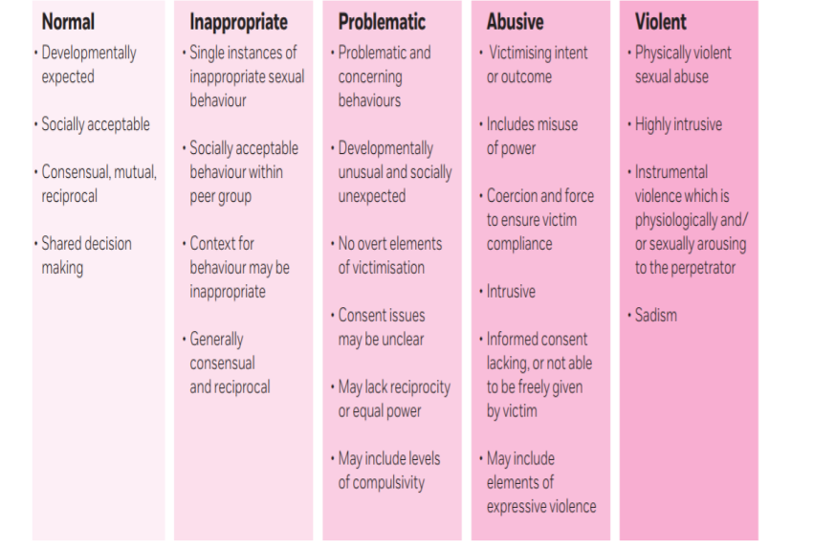
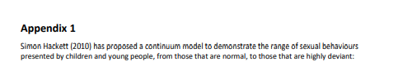
Continuum Model of Sexual behaviours (Appendix 1)

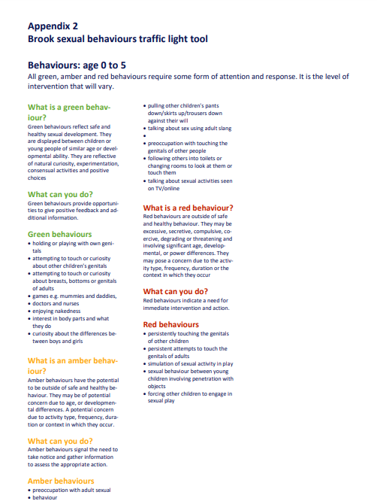
Brook Sexual Behaviours Traffic Light Tool (Appendix 2)
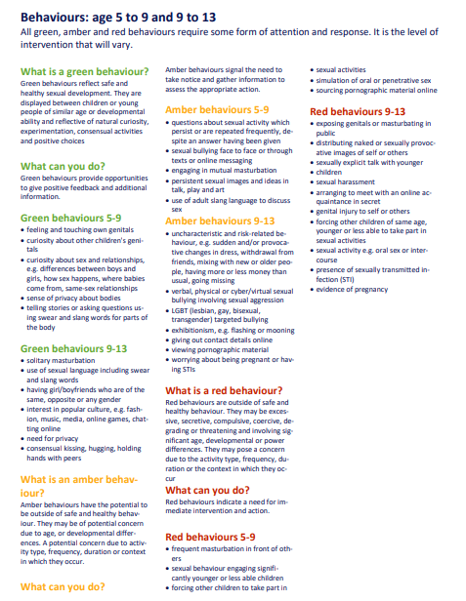

Keeping Children Safe in Education 2026 - Part five; Child-on-child sexual violence and sexual harassment (Appendix 3)
Part five: Child-on-child sexual violence and sexual harassment
450. This part of the statutory guidance is about how schools and colleges should respond to all signs, reports and concerns of child-on-child sexual violence and sexual harassment, including those that have happened outside of the school or college premises, and/or online (what to look out for and indicators of abuse are set out in Part one of this guidance). As set out in Part one of this guidance, all staff working with children are advised to maintain an attitude of ‘it could happen here’, and this is especially important when considering child-onchild abuse.
What schools and colleges should be aware of
451. Sexual violence and sexual harassment can occur between two or more children of any age and sex, from primary through to secondary stage and into college. It can occur also through a group of children sexually assaulting or sexually harassing a single child or group of children. Sexual violence and sexual harassment exist on a continuum and may overlap; they can occur online and face to-face (both physically and verbally) and are never acceptable. Schools and colleges should be aware of the importance of:
• making clear that there is a zero-tolerance approach to sexual violence and sexual harassment, that it is never acceptable, and it will not be tolerated. It should never be passed off as “banter”, “just having a laugh”, “a part of growing up” or “boys being boys”. Failure to do so can lead to a culture of unacceptable behaviour, an unsafe environment and in worst case scenarios a culture that normalises abuse, leading to children accepting it as normal and not coming forward to report it
• recognising, acknowledging, and understanding the scale of harassment and abuse and that even if there are no reports it does not mean it is not happening, it may be the case that it is just not being reported
• challenging physical behaviour (potentially criminal in nature) such as grabbing bottoms, breasts and genitalia, pulling down trousers, flicking bras and lifting up skirts. Dismissing or tolerating such behaviours risks normalising them
452. Children who are victims of sexual violence and sexual harassment wherever it happens, may find the experience stressful and distressing. This will, in all likelihood, adversely affect their educational attainment and will be exacerbated if the alleged perpetrator(s) attends the same school or college.
453. Whilst any report of sexual violence or sexual harassment should be taken seriously, staff should be aware it is more likely girls will be the victims of sexual violence and sexual harassment and more likely it will be perpetrated by boys.
Children with disabilities are also three times more likely to be abused than their peers
454. Ultimately, it is essential that all victims are reassured that they are being taken seriously and that they will be supported and kept safe.
Sexual violence
455. It is important that schools and colleges are aware of sexual violence and the fact children can, and sometimes do, abuse other children in this way and that it can happen both inside and outside of school/college. When referring to sexual violence in this advice, we do so in the context of child-on-child sexual violence.

When referring to sexual violence we are referring to sexual offences under the Sexual Offences Act 2003136 as described below:
Rape: A person (A) commits an offence of rape if: he intentionally penetrates the vagina, anus or mouth of another person (B) with his penis, B does not consent to the penetration and A does not reasonably believe that B consents.
Assault by penetration: A person (A) commits an offence if: s/he intentionally penetrates the vagina or anus of another person (B) with a part of her/his body or anything else, the penetration is sexual, B does not consent to the penetration and A does not reasonably believe that B consents.
Sexual assault: A person (A) commits an offence of sexual assault if: s/he intentionally touches another person (B), the touching is sexual, B does not consent to the touching and A does not reasonably believe that B consents. (NOTE - Schools and colleges should be aware that sexual assault covers a very wide range of behaviour so a single act of kissing someone without consent or touching someone’s bottom/breasts/genitalia without consent, can still constitute sexual assault).
Causing someone to engage in sexual activity without consent: A person (A) commits an offence if: s/he intentionally causes another person (B) to engage in an activity, the activity is sexual, B does not consent to engaging in the activity, and A does not reasonably believe that B consents. (NOTE – this could include forcing someone to strip, touch themselves sexually, or to engage in sexual activity with a third party).
Jones, L et al. (2012) Prevalence and risk of violence against children with disabilities: a systematic review and meta-analysis of observational studies. The Lancet July 2012. Sexual Offences Act 2003 (Legislation.gov.uk).
What consent is? Consent is about having the freedom and capacity to choose.
Consent to sexual activity may be given to one sort of sexual activity but not another, e.g. to vaginal but not anal sex or penetration with conditions, such as wearing a condom. Consent can be withdrawn at any time during sexual activity and each time activity occurs. Someone consents to vaginal, anal or oral penetration only if s/he agrees by choice to that penetration and has the freedom and capacity to make that choice.
• a child under the age of 13 can never consent to any sexual activity
• the age of consent is 16
• sexual intercourse without consent is rape
Further information about consent can be found here: Rape Crisis England & Wales - Sexual consent
Sexual harassment
456. When referring to sexual harassment we mean ‘unwanted conduct of a sexual nature’ that can occur online and offline and both inside and outside of school or college. When we reference sexual harassment, we do so in the context of child-on-child sexual harassment. Sexual harassment is likely to: violate a child’s dignity, and/or make them feel intimidated, degraded or humiliated and/or create a hostile, offensive or sexualised environment.
457. Whilst not intended to be an exhaustive list, sexual harassment can include:
• sexual comments, such as telling sexual stories, making lewd comments, making sexual remarks about clothes and appearance and calling someone sexualised names
• sexual “jokes” or taunting
It is important school and college staff (and especially designated safeguarding leads and their deputies) understand consent. This will be especially important if a child is reporting they have been raped or sexually assaulted in any way. Further information can be found at Rape Crisis
PSHE Teaching about consent from the PSHE association provides advice and lesson plans to teach consent at Key stage 3 and 4.
It is important to differentiate between consensual sexual activity between children of a similar age and that which involves any power imbalance, coercion or exploitation. Due to their additional training, the designated safeguarding lead (or a deputy) should be involved and generally speaking leading the school or college response. If in any doubt, they should seek expert advice.
• physical behaviour, such as deliberately brushing against someone, interfering with someone’s clothes. Schools and colleges should be considering when any of this crosses a line into sexual violence – it is important to talk to and consider the experience of the victim
• displaying pictures, photos or drawings of a sexual nature
• upskirting (this is a criminal offence140)
• online sexual harassment. This may be standalone, or part of a wider pattern of sexual harassment and/or sexual violence.141 It may include:
o consensual and non-consensual sharing of nude and semi-nude images and/or videos.142 Taking and sharing nude photographs of those aged under 18 is a criminal offence. UKCIS Sharing nudes and semi-nudes: advice for education settings working with children and young people provides detailed advice for schools and colleges
o sharing of unwanted explicit content
o sexualised online bullying
o unwanted sexual comments and messages, including, on social media
o sexual exploitation; coercion and threats, and
o coercing others into sharing images of themselves or performing acts they’re not comfortable with online
458. It is important that schools and colleges consider sexual harassment in broad terms. Sexual harassment (as set out above) creates a culture that, if not challenged, can normalise inappropriate behaviours and provide an environment that may lead to sexual violence.
Harmful sexual behaviour
459. Children’s sexual behaviour exists on a wide continuum, ranging from normal and developmentally expected to inappropriate, problematic, abusive and violent. Problematic, abusive and violent sexual behaviour is developmentally inappropriate and may cause developmental damage. A useful umbrella term is
The Voyeurism (Offences) Act 2019 which amends the Sexual Offences Act 2003 to make upskirting a specific offence of voyeurism. The Act came into force on 12 April 2019.
141Project deSHAME from Childnet provides useful research, advice and resources regarding online sexual harassment.
142 Consensual image sharing, especially between older children of the same age, may require a different response. It might not be abusive – but children still need to know it is illegal- whilst non-consensual is illegal and abusive.
“harmful sexual behaviour” (HSB). The term has been widely adopted in child protection and is used in this advice. HSB can occur online and/or face-to-face and can also occur simultaneously between the two. HSB should be considered in a child protection context.
460. When considering HSB, both ages and the stages of development of the children are critical factors. Sexual behaviour between children can be considered harmful if one of the children is much older, particularly if there is more than two years’ difference or if one of the children is pre-pubescent and the other is not.
However, a younger child can abuse an older child, particularly if they have power over them, for example, if the older child is disabled or smaller in stature.
Confidential specialist support and advice on HSB is available from the specialist sexual violence sector and sources are listed in Annex B.
461. It is effective safeguarding practice for the designated safeguarding lead (and their deputies) to have a good understanding of HSB. This could form part of their safeguarding training. This will aid in planning preventative education, implementing preventative measures, drafting and implementing an effective child protection policy and incorporating the approach to sexual violence and sexual harassment into the whole school or college approach to safeguarding.
462. HSB can, in some cases, progress on a continuum.143 Addressing inappropriate behaviour can be an important intervention that helps prevent problematic, abusive and/or violent behaviour in the future. Children displaying HSB have often experienced their own abuse and trauma.144 It is important that they are offered appropriate support.
Preventing abuse
HSB framework and audit | NSPCC Learning discusses the continuum harmful behaviour can progress on (Hackett 2019 continuum model).
Hackett et al 2013 study of children and young people with harmful sexual behaviour suggests that two thirds had experienced some kind of abuse or trauma.
463. Effective safeguarding practice is demonstrated when schools and colleges are clear, in advance, about what local processes are in place and what support can be accessed when sexual violence or sexual harassment has occurred. It is important to prepare for this in advance and review this information on a regular basis to ensure it is up to date. As such:
• if required, the designated safeguarding lead (or a deputy) should discuss the local response to sexual violence and sexual harassment with police and local authority children’s social care colleagues in order to prepare the schools or college’s policies (especially the child protection policy) and responses, and violence and sexual harassment and be confident as to how to access this support when required. Further information on specialist support and interventions can be found in Annex B in the additional advice and support section under “sexual violence and sexual harassment”.
• the designated safeguarding lead (and their deputies) should be confident as to what local specialist support is available to support all children involved (including victims and alleged perpetrators) in sexual
Responding to reports of sexual violence and sexual harassment
464. Part two of this guidance is clear that systems should be in place (and they should be well promoted, easily understood and easily accessible) for children to confidently report abuse, knowing their concerns will be treated seriously.
465. Reports of sexual violence and sexual harassment are likely to be complex and require difficult professional decisions to be made, often quickly and under pressure. Pre-planning, effective training and effective policies will provide schools and colleges with the foundation for a calm, considered and appropriate response to any reports. Governing bodies and proprietors should ensure that the school or college contributes to multi-agency working in line with statutory guidance Working Together to Safeguard Children (and as summarised in Part two of this guidance).
466. This part of the guidance does not attempt to provide (nor would it be possible to provide) detailed guidance on what to do in any or every case. The guidance provides effective safeguarding practice and principles for schools and colleges to consider in their decision-making process.
467. Ultimately, any decisions are for the school or college to make on a case-by case basis, with the designated safeguarding lead (or a deputy) taking a leading role and using their professional judgement, supported by other agencies, such as local authority children’s social care and the police as required.
468. The guidance also provides case studies. These are not intended to offer a step-by-step guide, but to provide an indication of some of the various options that are available to respond to reports of sexual violence and sexual harassment.
Support for schools and colleges
469. Schools and colleges should not feel that they are alone in dealing with sexual violence and sexual harassment.
470. Local authority children’s social care and the police will be important partners where a crime might have been committed. Referrals to the police will often be a natural progression of making a referral to local authority children’s social care. The designated safeguarding lead (or a deputy) should lead the school or college response and should be aware of the local process for referrals to children’s social care and making referrals to the police (also see the section ‘Reporting to the police’ on page 128 for further information). Schools and colleges may also find the following resources helpful:
• National Crime Agency’s CEOP Safety Centre aims to keep children and young people safe from online sexual abuse. Online sexual abuse can be reported on their website and a report made to one of its Child Protection Advisors.
• The NSPCC provides a helpline for professionals at 0808 800 5000 and help@nspcc.org.uk. The helpline provides expert advice and support for school and college staff and will be especially useful for the designated safeguarding lead (and their deputies).
• Support from specialist sexual violence sector organisations such as Rape Crisis or The Survivors Trust.
• The Anti-Bullying Alliance has developed guidance for schools about Sexual and sexist bullying.

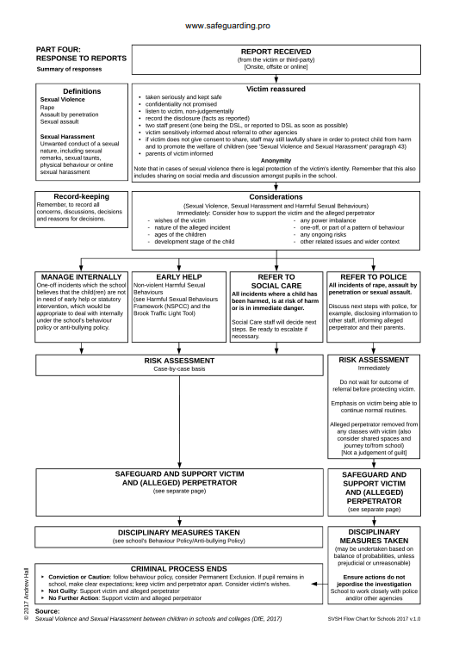
Response Flowchart for Sexual Violence or Sexual Harassment (Appendix 4)
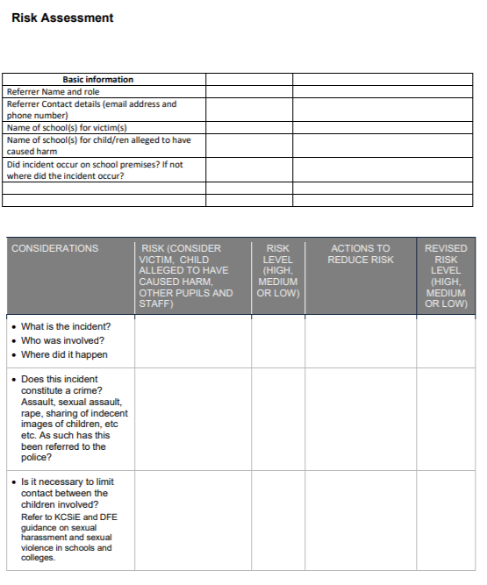
Risk Assessment for incidents of Sexual Violence or Sexual Harassment (Appendix 5)



