Relationships Education Policy

Swanbourne CE School

Mursley CE School

Drayton Parslow Village School

Kingfishers Pre-School (Mursley)

(In this policy known as the Three Schools)



This policy was agreed by the Governing Body– July 2026

This policy will be reviewed – July 2028

(Copies of this policy are available for staff, parents, visitors and
volunteers on request from the school office)

- School ethos / values statement
At The Three Schools we are committed to providing a holistic approach to education which aims to support the academic, cultural, personal and social development of all our pupils. Statutory Relationships Education and Health Education will be part of the taught PSHE curriculum. PSHE is an essential part of a child’s education. High quality PSHE significantly contributes to personal and academic success, supporting all pupils to Achieve, Belong and Thrive. This policy has been revised to reflect the New statutory RSHE guidance published July 2025.
2. Aims of the Relationships/RSE policy
All state funded primary schools are required to teach Relationships Education and to have a Relationships Education policy or an RSE policy if teaching non statutory Sex Education.
The aim of this policy is to:
- Provide information to staff, parents and carers, governors, pupils and other agencies regarding the organisation, content and approach to teaching Relationships/RSE Education
- Help parents and carers to understand Relationships Education/ Sex Education and support them to work with their child to secure the very best outcomes for all pupils
- Demonstrate how the school meets legal requirements with regards to teaching Relationships Education/ Sex Education
Legal Requirements
To comply with The Relationships Education, Relationships and Sex Education and Health Education (England) Regulations 2019, made under sections 34 and 35 of the Children and Social Work Act 2017, make Relationships Education compulsory for all pupils receiving primary education. They also make Health Education compulsory in all schools except independent schools.

To comply with the Relationships Education, Relationships and Sex Education (RSE) and Health Education statutory guidance from the DfE (July 2025)

To comply with the requirement s to have an up-to-date Relationships/RSE policy developed in consultation parents and carers (Education Act 1996) and in line with the DfE statutory guidance on Relationships Education, RSE and Health Education (July 2025)

To have due regard to the Equality Act (2010) which requires schools to prevent discrimination, advance equality of opportunity and foster good relation between different groups. The protected characteristics that apply to school age children are disability, race, religion or belief, sex, sexual orientation, gender reassignment, pregnancy and maternity.

To fulfil statutory safeguarding duties and ensure any safeguarding issues arising from Relationships /RSE teaching are identified and followed in accordance with the school safeguarding policy and to comply with current KCSIE statutory requirements.

3. Development of the policy
This policy was developed by the PSHE lead in consultation with school governors, parents and pupils.
This policy links to the PSHE policy, Child Protection Policy, Anti-Bullying Policy, Equalities policy and the School Behaviour policy.
Statutory Relationships Education and non-statutory sex education is taught through the Personal, Social, Health and Economic Education (PSHE) curriculum. The personal, social, health and economic development of our pupils is a vital element of education and we aim to work collaboratively with parents/ carers to ensure children are well informed and supported to make healthy, safe and positive choices in all aspects of their daily lives and support them to achieve, belong and thrive. An overview of PSHE can be found on the school website https://www.threeschools.org/pshe and is included in curriculum information for each term/ year. We are committed to working in partnerships and welcome parents and carers to make an appointment to discuss any aspect of this policy, resources and RSE provision in school.
4. Relationships Education
Statutory Relationships Education at The Three Schools is taught through the PSHE curriculum and teaches pupils what they need to know by the end of year 6 as defined by the DfE guidance (See appendix 1). We use Kapow resources to teach Relationships Education, a statutory aspect of PSHE.
Relationships Education gives pupils the information they need to help them develop healthy, nurturing relationships with other children and adults. It should enable them to know what a healthy relationship looks like, how to build and maintain happy, healthy relationships with others and recognise the importance of a range of relationships with friends, family, in school and in wider community in which they live. Relationships Education also teaches pupils to recognise unhealthy behaviours, how to keep safe, identify potential dangers in their online and offline lives and how to report any concerns or abuse and where to access help when needed.
Why teach Relationships Education?
High quality Relationships Education will support pupils to:
- Form and maintain positive relationships with other children and adults
- Understand the importance of positive and healthy relationships on their wellbeing
- Recognise what makes a good friendship and how to be a good friend in return
- Strategies to manage the ups and downs of friendships and relationships with others
- Show respect for others and recognise diversity within relationships, treating each other with kindness, consideration and understanding
- Develop positive character traits and personal attributes such as self- respect, kindness, honesty, integrity and resilience
- Positively engage in social action and contribute to the wellbeing of others
- Understand the principles of positive relationships also apply online, how to keep safe and how to report concerns
- Understand the importance of recognising and establishing their own personal boundaries and privacy
- Understand and respect differences and combat all forms of bullying and discrimination
- Recognise unhealthy relationships, inappropriate behaviour and bullying and to report concerns or abuse and are taught the appropriate vocabulary to do so (including signposting to trusted online support services such as Childline)
- Ask a trusted adult rather than go online with regards to any concerns about relationship issues and avoid viewing any inappropriate material or entering into social media conversations that can cause them harm
- Recognise intimate physical relationships are for adults
Relationships education is delivered through the PSHE curriculum. These aspects of the Relationships Education as defined by the DfE, will be taught at an age-appropriate level. (See Appendix 1 for further details).

To ensure the content and delivery of Relationships Education is appropriate and relevant to our pupils we use simple baselines to ascertain what pupils already know and find out what they would like to learn.
Distancing techniques are used to teach relationships education, which provides depersonalised examples which support children to explore what, is being taught without sharing their own personal experiences in the lesson.
We provide an inclusive curriculum that promotes understanding and mutual respect for all. We reflect diversity within our curriculum to ensure that no pupil feels excluded and teach pupils to respect difference, promote equality and challenge stigma.
Outcomes for Relationships Education by the end of year 6 is taught through the themes below:

- Families and people who care for me

- Caring friendships

- Respectful, kind relationships

- Online safety and awareness

- Being safe

How delivery and content will be made accessible to all pupils including SEND
The school is committed to ensuring that RSE and PSHE education is accessible and inclusive for all pupils, including those with SEND. Teaching is differentiated and adapted to meet individual needs through the use of appropriate resources, teaching strategies and reasonable adjustments. Lessons are delivered in a safe and supportive environment, enabling every pupil to participate, develop understanding and achieve the intended learning outcomes in a manner that is appropriate to their age, stage of development and individual needs.
Where you can view curriculum information (Please see Appendix 2) for year by year overview of the PSHE provision and where we cover Relationships Education.
5. Sex Education
At The Three Schools, we teach Sex Education as part of our Relationships and PSHE curriculum in Year 6. Although non statutory at Primary, Sex Education is highly recommended by the DfE , supports safeguarding and provides a trusted source of factual information for pupils. Sex Education at The Three Schools is taught through the PSHE curriculum as part Relationships Education. Sex education is taught in addition to the statutory science curriculum and provides factual and age-appropriate knowledge about conception and birth. In preparation for the secondary RSE curriculum, sex education teaches pupils to recognise the difference between intimate and non-intimate relationships, promotes healthy committed relationships including marriage, consent and the values and responsibilities required to build healthy adult relationships. It also teaches pupils the legal age for marriage and consensual sexual relationships, to recognise their right to their own physical and emotional personal space, how to keep themselves safe, and how to report concerns or issues. Puberty Education is part of statutory Health Education and parents/cares do not have the right to withdraw their child from this aspect of the curriculum.
High quality sex education will enable our pupils to:
- Have a factual and age-appropriate understanding of how babies are made and born
- Understand that intimate and sexual relationships are a natural part of adult life
- Know who to talk to if they have further questions about sex and intimate relationships
- Be aware of and respect different types of relationships in accordance with the Equalities Act
- Know they will continue to learn about sex education in their secondary school
- Keep themselves safe online, recognising risks, harmful content, and online contact and be able to report any concerns at the earliest stage
- Know how to keep safe by recognising any inappropriate behaviour from others
- Report concerns or abuse and have the confidence, knowledge and vocabulary to do so
What materials do we use? We use the Kapow programme of study.
Who teaches this? The PSHE leader (Charlene Smuts) is responsible for leading and managing the subject. Teachers are responsible for delivering PSHE, Relationships Education and Sex Education.
When is Sex Education taught? – Sex Education part of the PSHE curriculum in Year 6.
Sex Education is not statutory at primary we wish to state the right of parents and carers to withdraw their child from designated Sex Education lessons. We encourage parents/ carers to make an appointment to come in and speak to Mr May (Executive Headteacher) about any concerns they may have. Requests for withdrawal should be put in writing using the form sent to parents via ParentMail prior to the Sex Education sessions in Summer term 2 in Year 6.
Pupils who are withdrawn from Sex Education will be provided with suitable alternative educational activities and appropriate supervision for the duration of the lessons from which they have been withdrawn. Pupils who have been withdrawn from sex education may still ask questions about reproduction and sex. The school will explain to the pupil that this is something their parents may wish to answer, and the school will inform the parents that child-initiated questions have been raised.
We highly recommend all students receive the full PSHE curriculum.
We keep parents/ carers informed about when sex education will take place. We offer dedicated parent sessions prior to sex education lessons, leaflets and guidance for parents/carers on the school website for further information. Parents /carers are welcome to make an appointment to view materials used to teach sex education. An overview of what is taught in each PSHE unit is available on the school website.
Pupils may ask questions about topics which go beyond any sex education covered by the school or relate to sex education from which they have been withdrawn. The school will encourage pupils to speak to their parents /carers and inform parents/carers that a conversation initiated by the pupil has taken place. If any safeguarding concerns are raised, the school will automatically follow safeguarding procedures.
How delivery and content will be made accessible to all pupils including SEND
The Three Schools are committed to ensuring that RSE and PSHE education is accessible and inclusive for all pupils, including those with SEND. Teaching is differentiated and adapted to meet individual needs through the use of appropriate resources, teaching strategies and reasonable adjustments. Lessons are delivered in a safe and supportive environment, enabling every pupil to participate, develop understanding and achieve the intended learning outcomes in a manner that is appropriate to their age, stage of development and individual needs.
Where you can view Relationships Education curriculum information? (See Appendix 2) for a year by year overview of the PSHE provision and where we cover Relationships Education).

6. Managing Difficult/Sensitive Questions
All aspects of PSHE are underpinned by shared and understood ground rules (See Appendix 3) with lessons being delivered in a safe and well managed environment. Pupils are encouraged to ask questions and raise issues in a respectful and appropriate manner. Some questions or issues raised may not be appropriately answered in whole class lessons and these will be followed up separately on an individual or group basis. A question box is available for pupils who do not feel confident to ask questions or wish to have a separate conversation with a member of staff. Given ease of access to the internet, children whose questions go unanswered may lead to them accessing inappropriate sources of information. We also respect that some questions are better addressed at home with parents/ carers and the school will share information with parents/carers on an individual basis should the need arise.
Teachers may suggest a pupil to speaks to their parents or a trusted adult, signpost to support services where needed, and recognising that children whose questions go unanswered might instead turn to inappropriate sources of information, including online.
Whilst it is vital to have trust and openness we cannot offer total confidentially to pupils. Any disclosures or areas of concern will be followed up in accordance with our safeguarding procedures.
7. Confidentiality and safeguarding
Any personal disclosures made by pupils will be followed up in accordance with the school’s child protection policy. Teachers will report any safeguarding concerns to the DLS and share concerns with parents/carers according to the school’s safeguarding procedures.
8. Roles and Responsibilities
It is the statutory responsibility of the governing body to ensure the school has a compliant and up to date Relationships/RSE policy. The Governing Body are required to approve the policy and hold the Headteacher to account for its implementation.
The Headteacher is responsible for ensuring PSHE is taught consistently across the school and for managing requests with regards to the parental right to withdraw from non-statutory Sex Education.
The PSHE lead is responsible for leading and managing PSHE which includes statutory Relationships Education. Teachers are responsible for delivering PSHE.
Pupils are expected to fully engage with PSHE provision and treat other with respect.
9. Working with outside agencies and visiting speakers
The Relationships Education programme will be led by the PSHE leads (Sarah Oliver and Kate Towse) and will be taught by Class Teachers and Teaching Assistants as appropriate. If we use the services of external contributors in some circumstances such as the delivery of Relationships Education, before a visitor is invited to take part in sessions, staff will ensure that they understand the ethos and values of The Three Schools, has a clear knowledge of the schools’ PSHE and Relationships Education programme of study and understands the objectives of the session and the aims and outcomes of the learning.
10. Monitoring, evaluation and training
PSHE provision will be monitored and evaluated by the PSHE leaders, SLT and Governors in line with the monitoring cycle agreed by the school. This policy will be reviewed annually.

To ensure staff are confident to deliver all aspects of the PSHE currciulum access to online, in school, local and national training will be made available and in accordance with the school’s CPD programme for staff development.

11. Working with parents and carers (consulting, informing and supporting)
Parents and cares are only entitled to withdraw their child form designated sex education lessons. Parents and carers do not have the right to withdraw their child from PSHE which includes statutory Relationships Education and Health Education (including the developing body/puberty). The science curriculum also includes content on human development, including reproduction, which there is no right to withdraw from. We highly recommend all students receive the full PSHE curriculum.
We consult with parents and carers whenever the RSE policy is reviewed or amended. We work in partnership to support parents to understand RSE education and have shared all RSE and PSHE updates during a consultation in July/August 2026. We have an open-door policy for parents to discuss any aspect of the RSE curriculum and their concerns or queries.
12. Policy monitoring and review
Policy monitoring and review
- We will formerly review this policy every year as well as if incidents occur that suggest the need for review.

- Parents/carers will be involved in policy review and monitoring via participation in and communication from The Three Schools’ PSHE working party which will include members or the LPPA parent action group.
David May (Executive Headteacher)
Kaye Rudd (Chair of Governors – Swanbourne)
Alison Terry (Chair of Governors – Mursley and Drayton Parslow)
Policy created – July 2026
Policy to be reviewed – July 2027
Appendix 1 DfE descriptors
https://www.gov.uk/government/publications/relationships-education-relationships-and-sex-education-rse-and-health-education/relationships-education-primary

Appendix 2 – PSHE curriculum overview

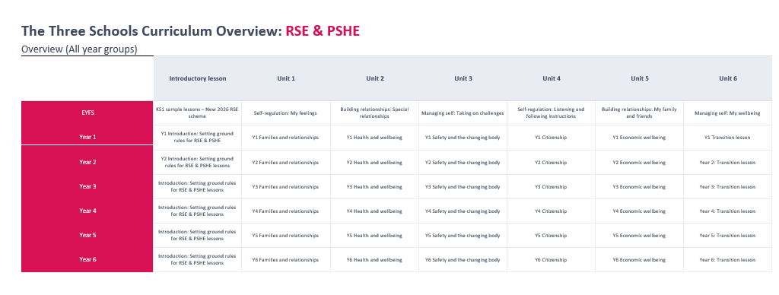

Appendix 3 – G.R.O.U.N.D Rules (Ground rules) for Relationships Education Lessons
Work with pupils to establish a list of Ground rules that will increase their feelings of safety and comfort during Relationships Education classes.
It is essential that the following ground rules be included:
- No personal questions or sharing of private information.
- You have the right to pass on a question.
- No question is silly or stupid.
- Use dictionary words whenever possible.
- Post the list in the classroom and refer to it as needed.

There is a balance between encouraging pupils to talk about real life and over disclosure of private information. Encourage pupils to use the phrase "Someone I know…" instead of the person's name if sharing information of a personal nature.
The Three Schools G.R.O.U.N.D rules for Relationships Education lessons;
G...Giggling is okay but laughing at others is not
R...Respect for myself and others is important
O...Option to pass on answering questions is available to all
U...Use dictionary words when describing the body
N...No question is a silly question!
D...Do use "Someone I know…" instead of the person's name

Appendix 4 – Skills and Knowledge progression for PSHE and RSE
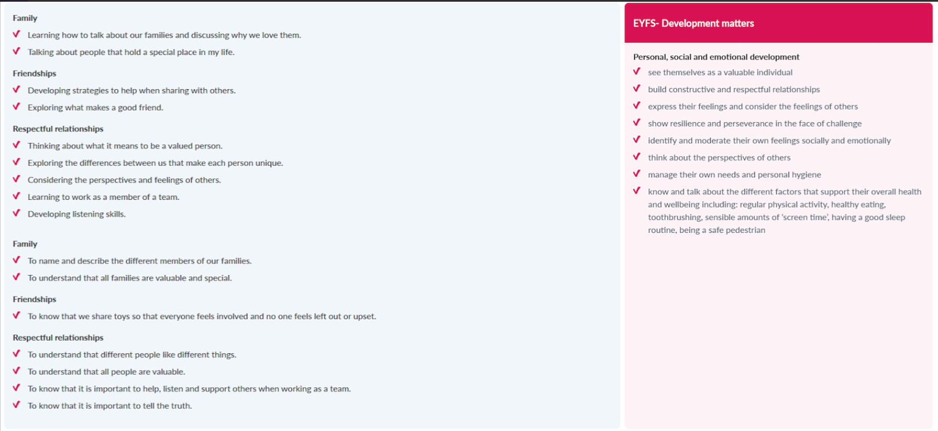
EYFS

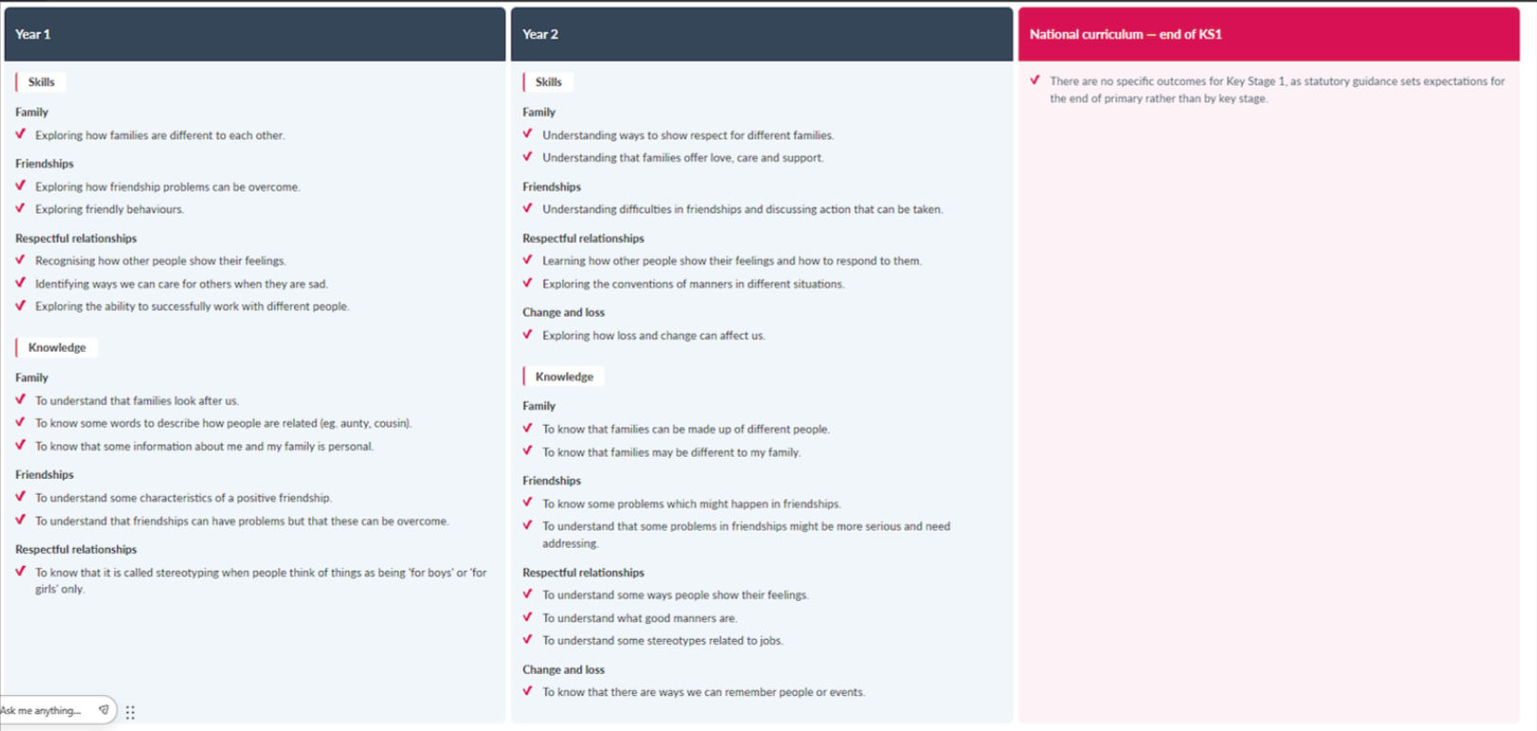
KS1

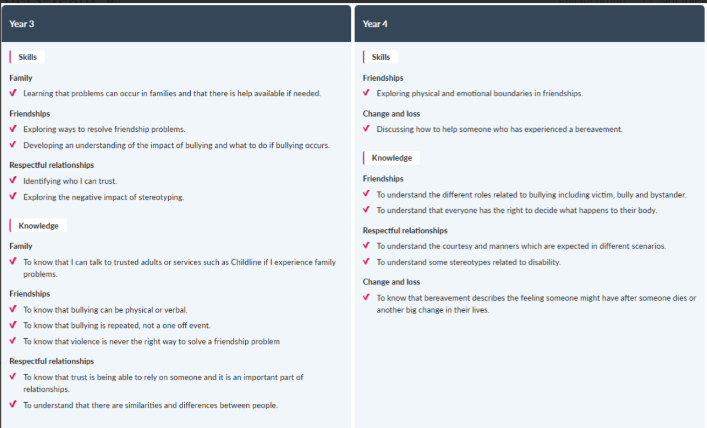
LKS2

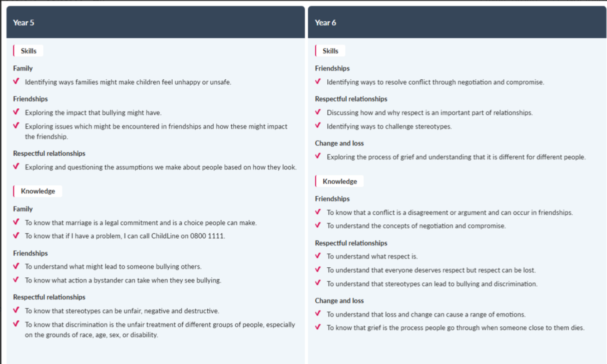
UKS2
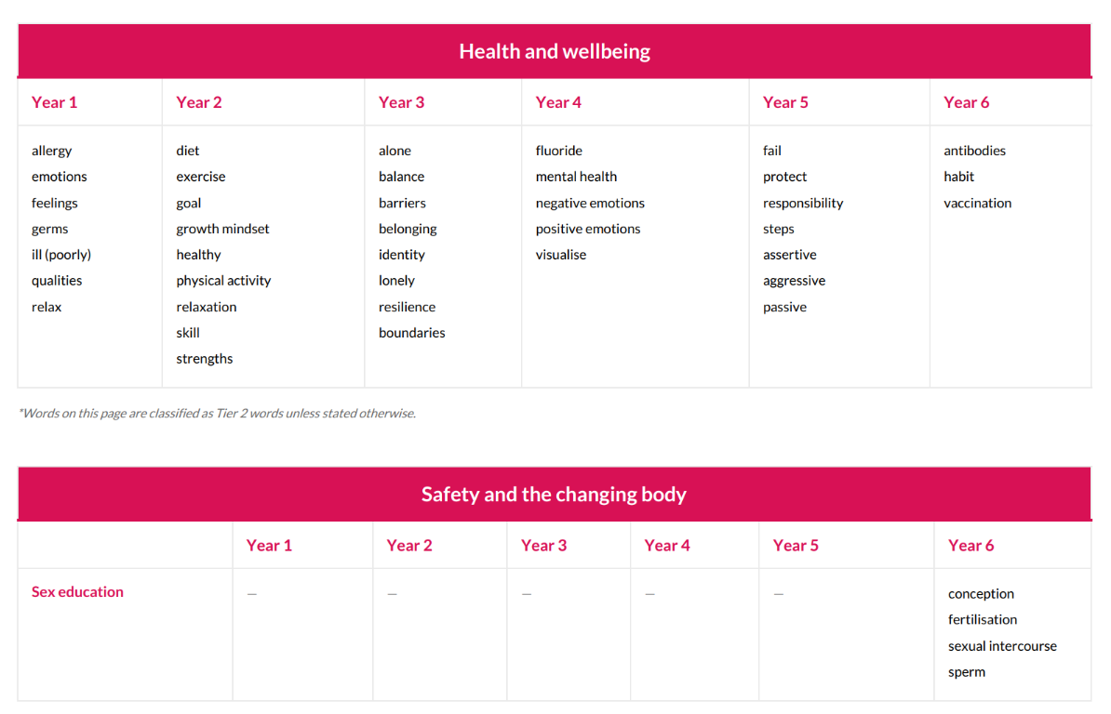
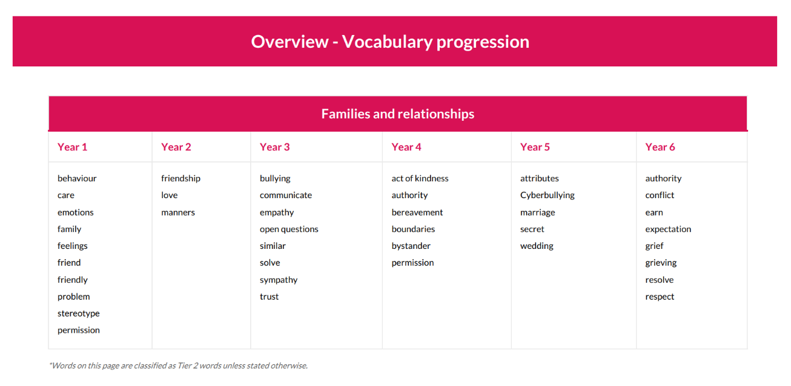
Appendix 5 – Vocabulary progression for PSHE and RSE



